Indian Ports Association (IPA)
Implementation of Port EBS Project
Enterprise Business System

Business Process Manual for
Open Tender – Two Bid System

Submitted by:

Plot No. 58 A & B,
Noida Special Economic Zone,
Uttar Pradesh-201305

www.techmahindra.com

This document is a desk reference tailored to the Procurement Specialists. It is intended to provide information that will be helpful to support the Tendering processes.
All rights reserved. Passing on and copying of this document, use and communication of its contents not permitted without written authorization
Document History:
Authors & Participants
Role | Name

Revision History
Date | Document  Version | Document Revision  Description | Author
01.07.2020 | 1.0 | Initial Draft | Sudhakar M S

Reviewed and Approved By
Name | Title | Date | Approved

Contents:
1. Buyer Logon 4
2. Sourcing 5
3. Publish RFx 20
4. Add Permission 24
5. Open Technical RFx 24
6. Display Technical Comparative Statement 28
7. Security & Committee Evaluation 30
8. Open Price Response 34
9. Display PCR Report 38
10. Create Purchase Order 40

Buyer Logon
  - Login to SRM Portal
  - Enter User ID and Password
  - Enter OTP from your registered mobile number

- Go to on Other Ebs Application and click “SRM Portal”

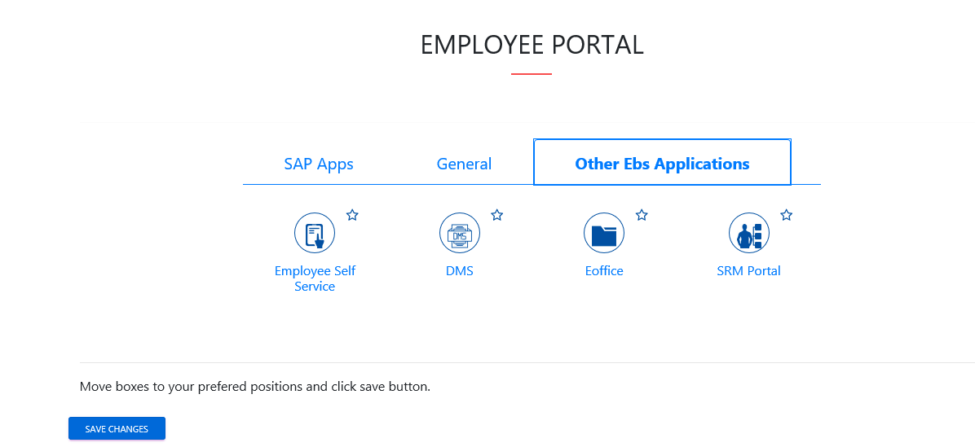

Sourcing
  - Click on Strategic Purchase -> Strategic Sourcing -> Carryout Sourcing
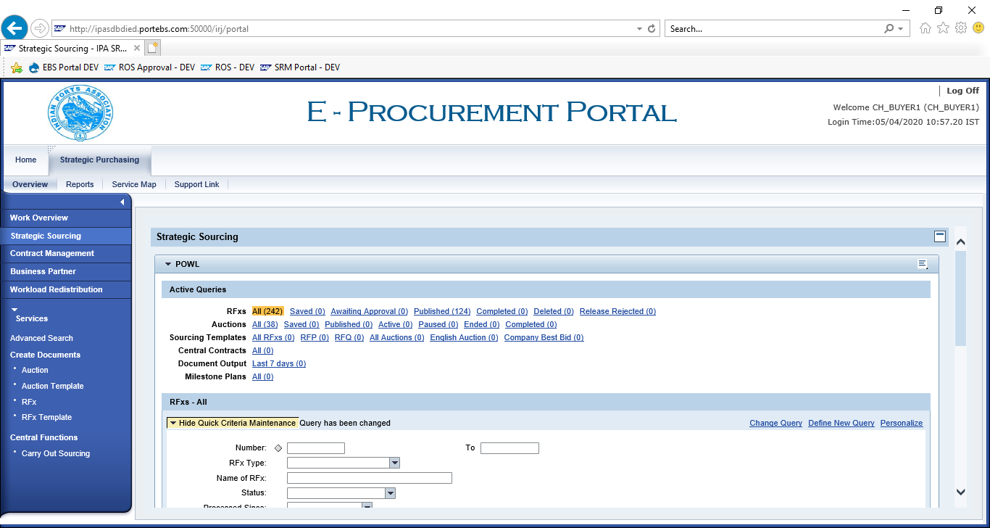

Enter SAP Purchase Requisition in “External Requisition” and click on “Search”. Purchase Requisition Line items shows below.
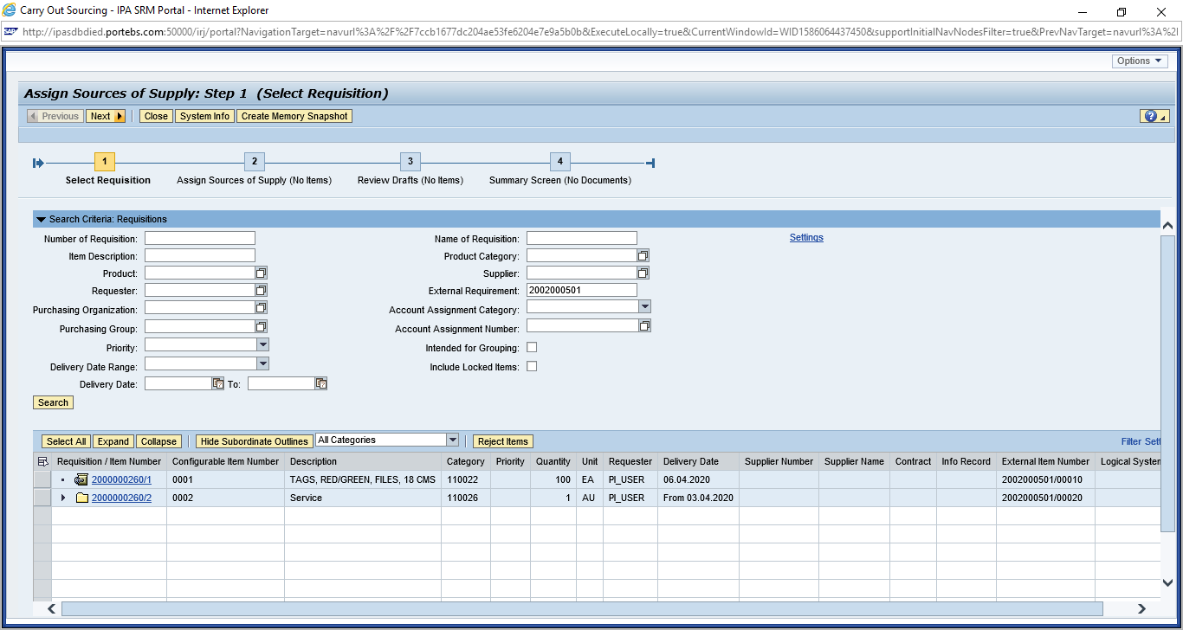
Click on “Select All” button and click on “Next” button.
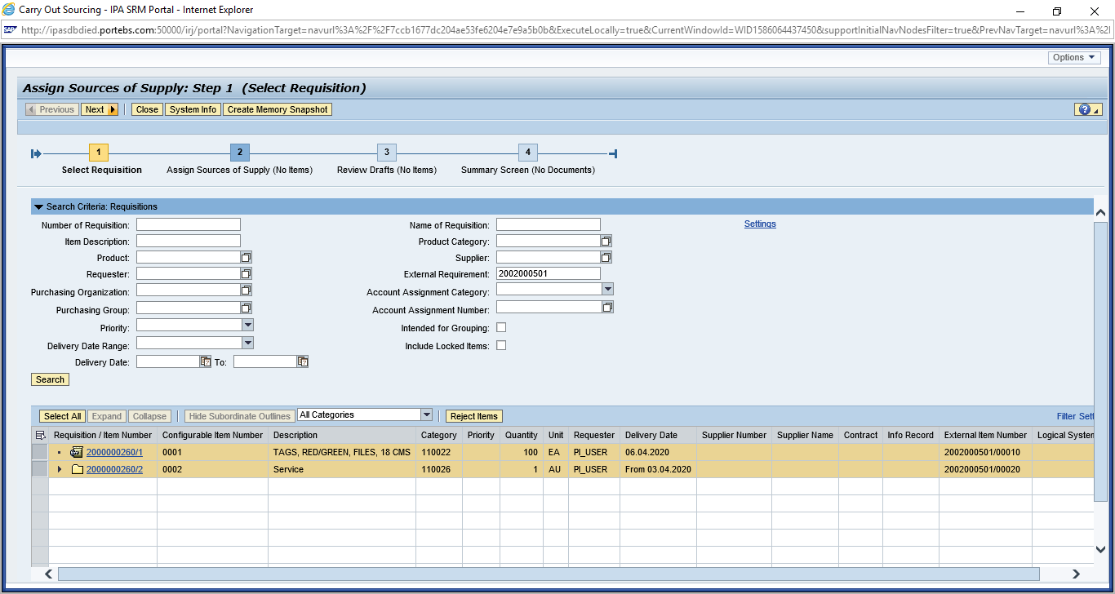
Click on “Select All” and Select “Create Draft” as “RFx”

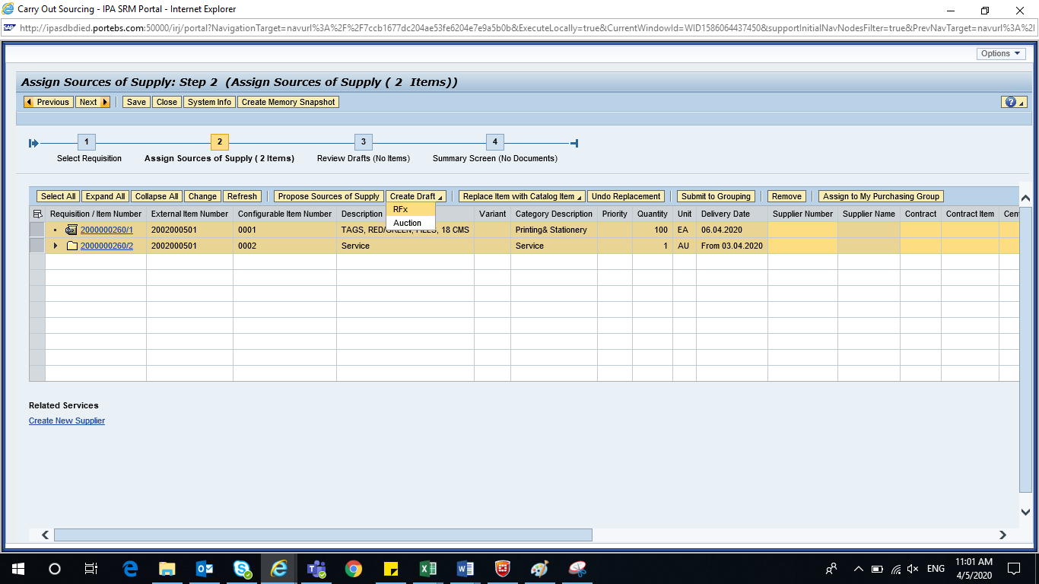

Select “Transaction Type” as “ZAT2 – Advt/Open Tender 2 Env”
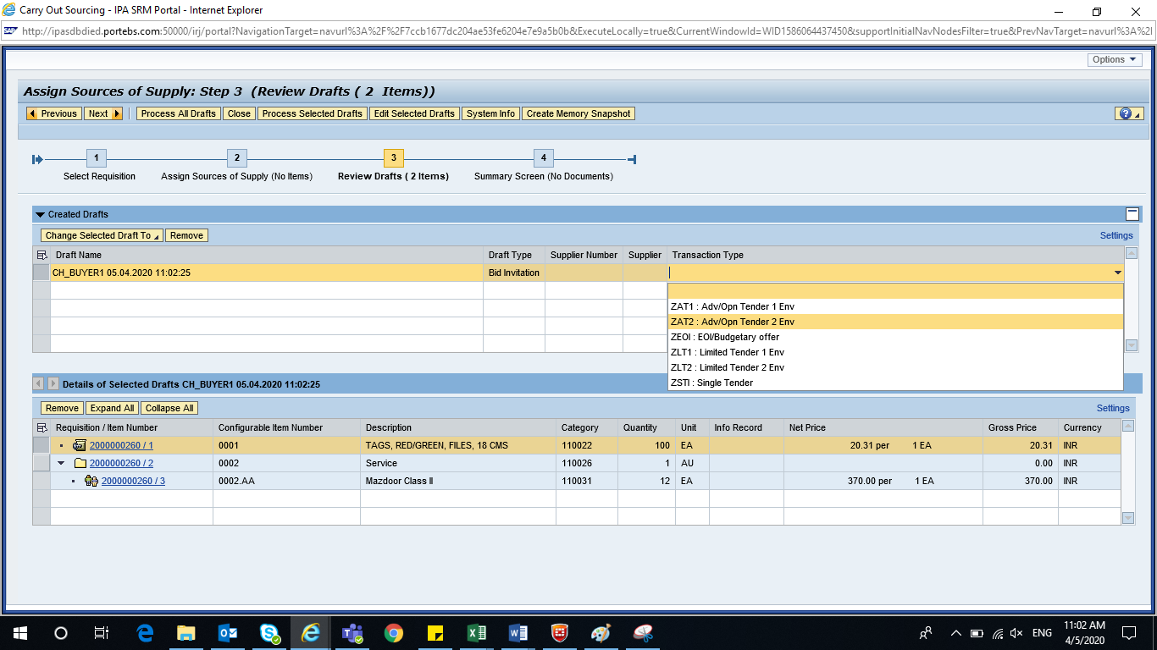
Click on “Process Selected Drafts”
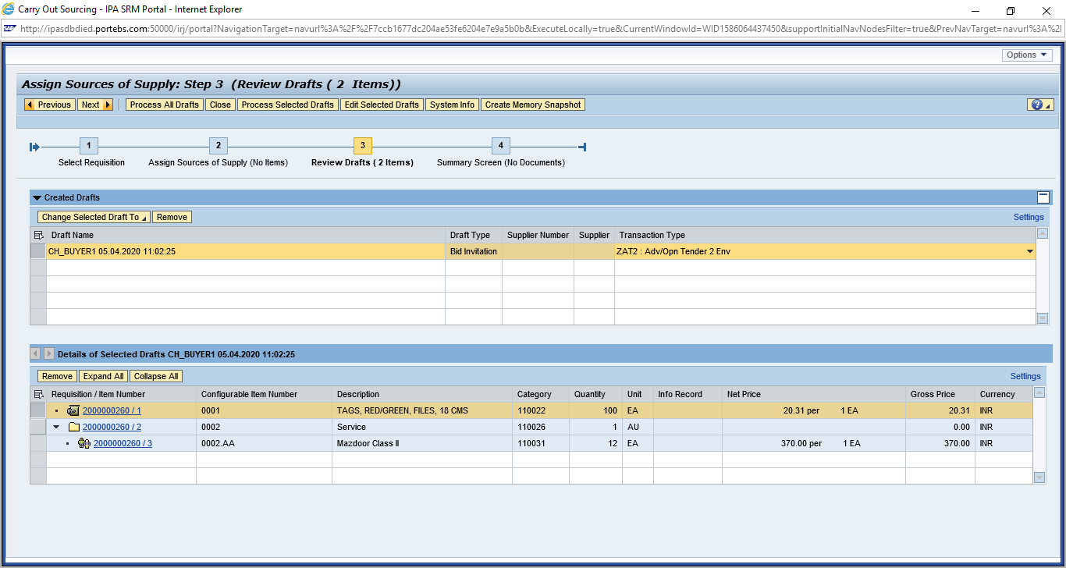

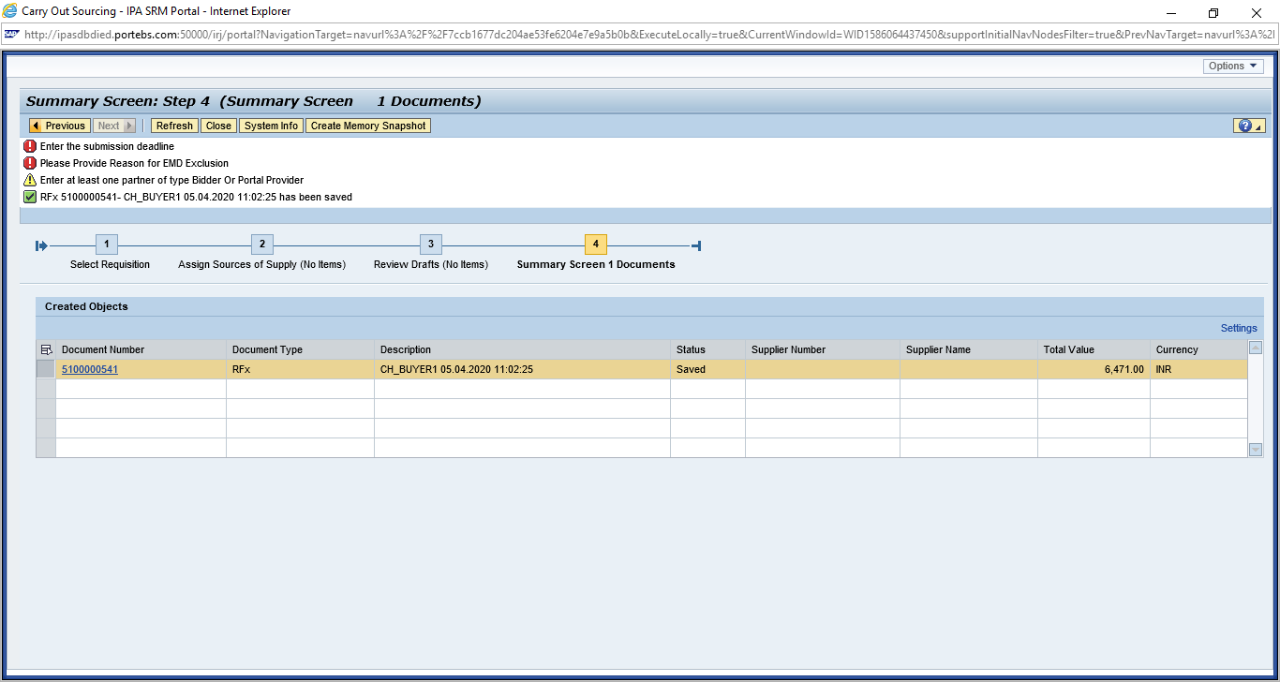
RFX Creation `
  - Display RFx
  - Go to “Strategic Purchasing” -> Strategic Sourcing”
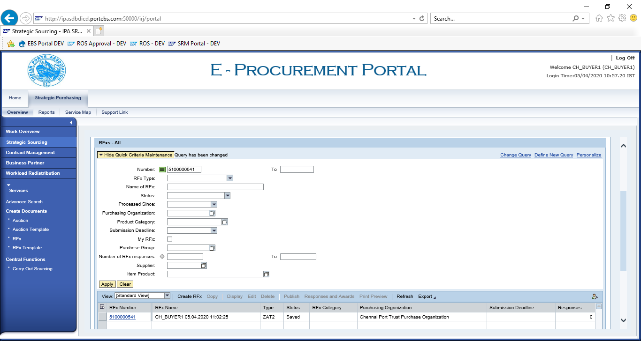

Enter RFx Number -> Apply -> Select RFx Number – Click “Display”

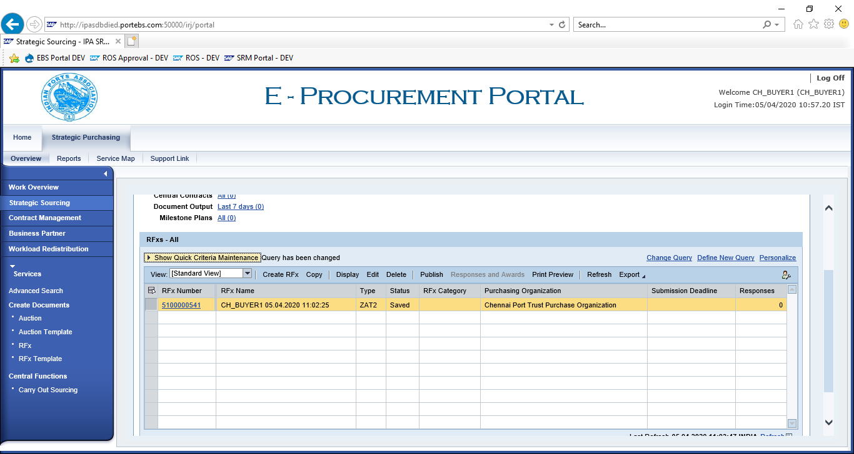

Click on “EDIT” and enter
    - RFx Number
    - Port Tender No
    - Tender Description

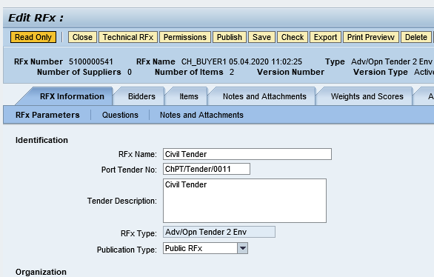

Enter RFx Dates
    - RFx Start Date
    - RFx Submission Date
    - Technical RFx Response Opening Date
    - Price RFx Opening Date
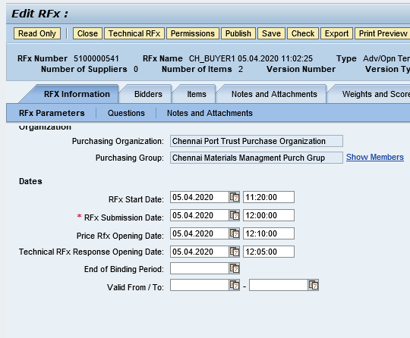

  - Enter Tender Fee, EMD and Security Deposit payment details
    - Tender Fee
      - Check Required checkbox
      - Enter Tender Fee Percentage or Tender Fee amount
      - Submission Deadline
    - Earnest Money Deposit (EMD)
      - Check Required checkbox
      - Enter EMD Percentage or amount
      - Submission Deadline
    - Security Deposit
      - Check Security Deposit checkbox
      - Security Deposit Percentage
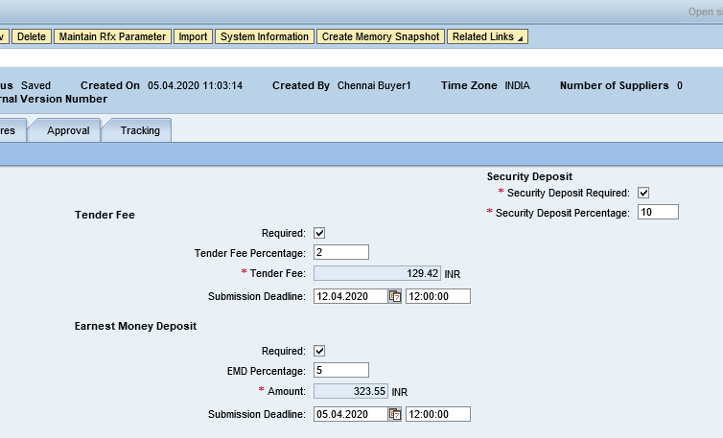

  - Pre-Bid Meeting
  - Check Pre-Bid Meeting Required checkbox
  - Enter Pre-Bid Start Date and End Date
  - Pre-Bid Location
  - Pre-Bid Remarks if required.
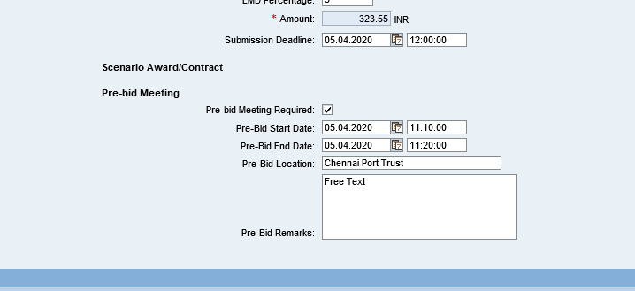
  - Click on “Maintain RFx Parameter” button
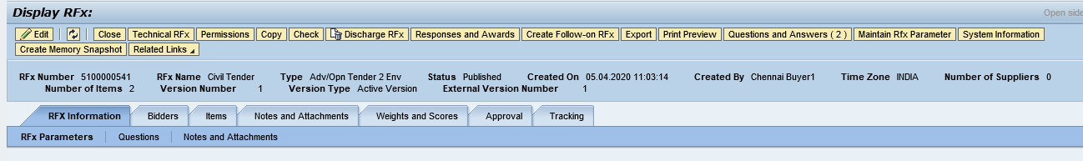
  - Click on “Import” button
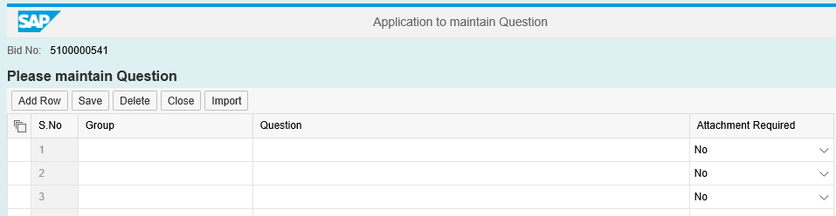

  - Click on “Select All” icon and click “Transfer” button
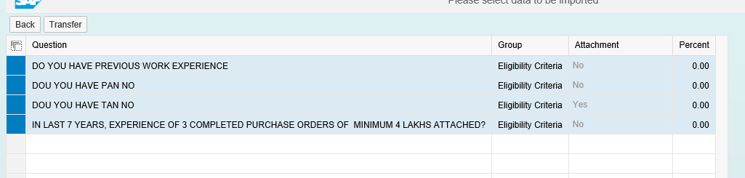
  - If want to add additional question, follow below steps
  - Click on “Add Row”
  - Select “Group” and enter “Question”
  - Click on “Save” button
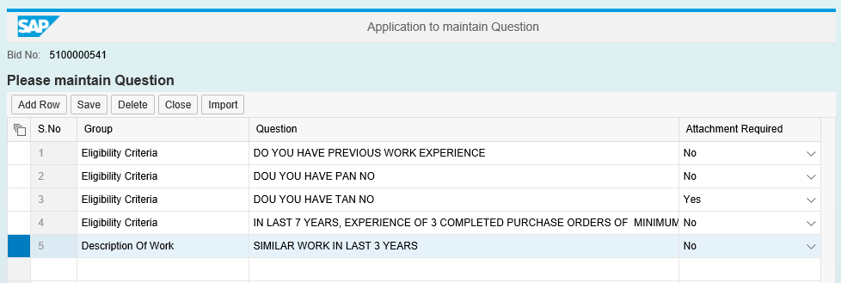

  - Questions are saved successfully.
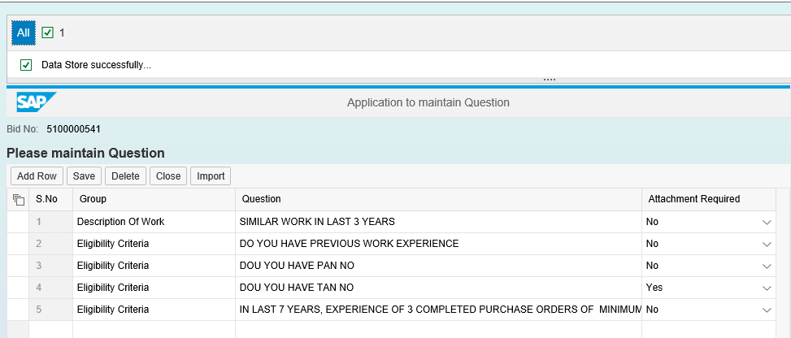
  - Click on “Technical RFx” to upload Tender documents
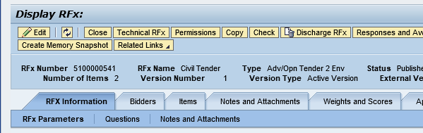

  - Click on “External Area” and click “Create”

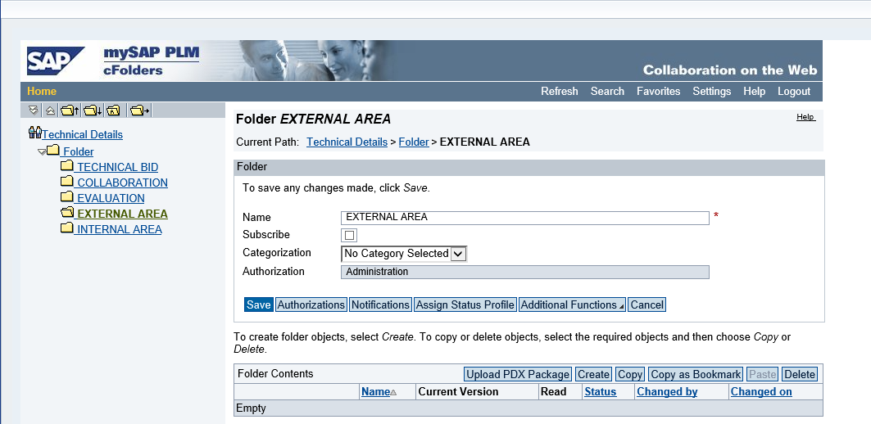
  - Click on “Document”
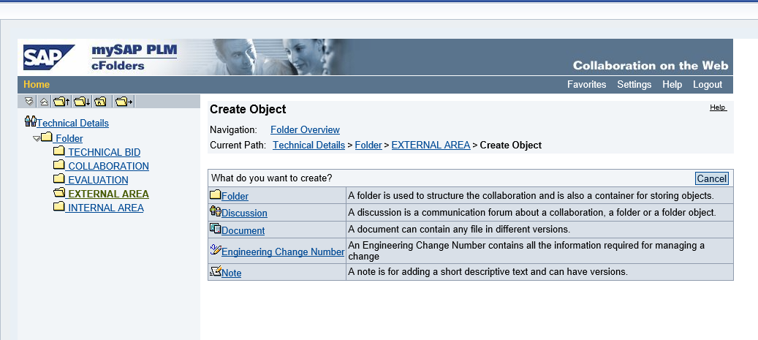

  - Enter upload file name, description and click “Continue”
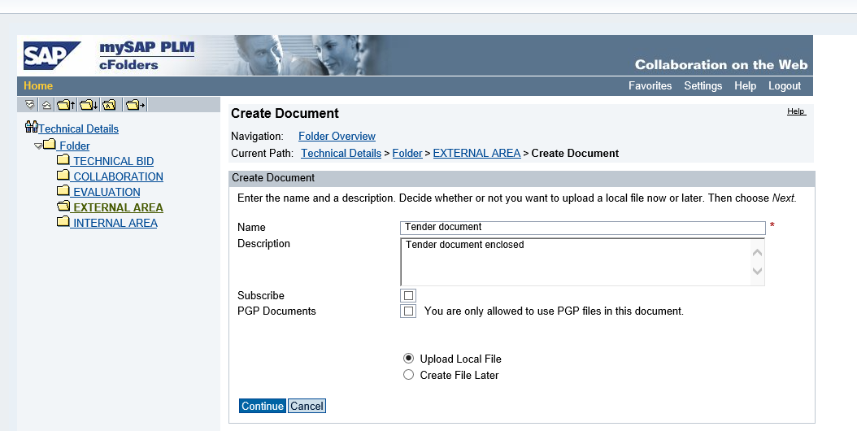
  - Upload file and click on “Save”
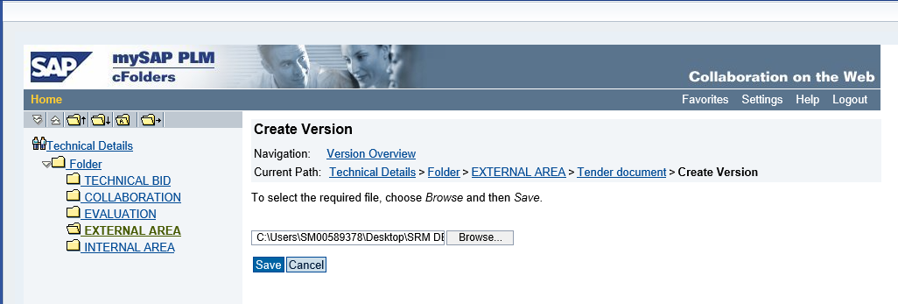

  - File uploaded successfully.
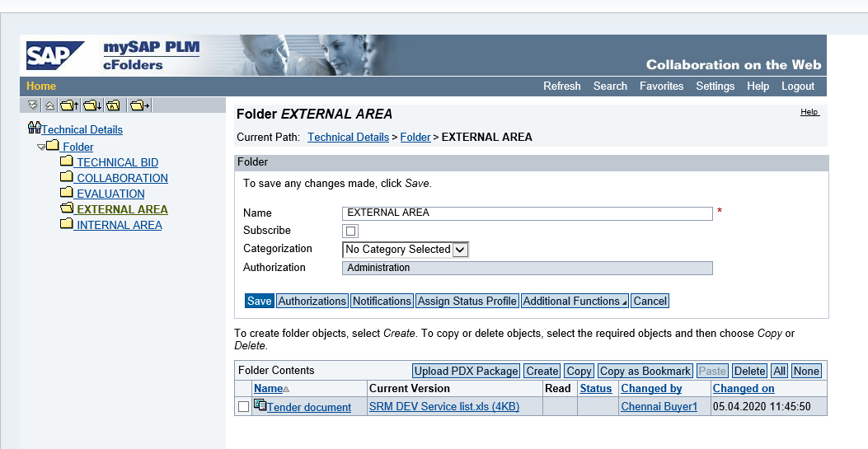
  - Click on “Check” button and ensure no error in RFx document.
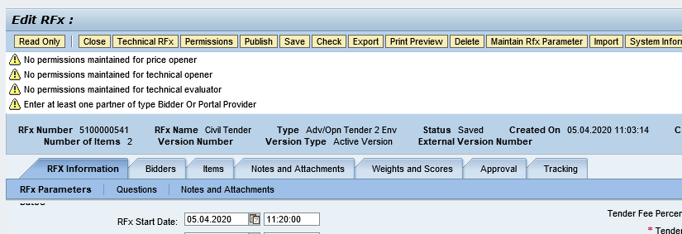

Publish RFx
  - Click on “Publish” to initiate for approval process.
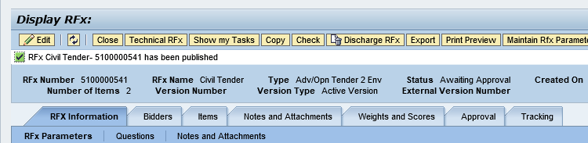

  - Logon as Approver
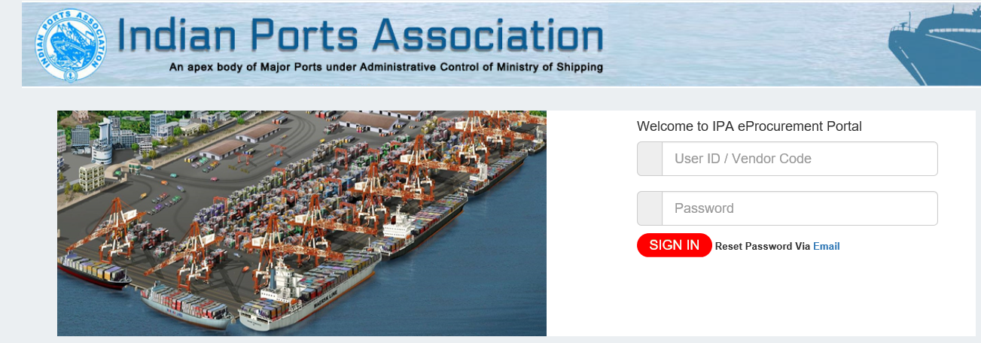
  - Enter User ID and Password
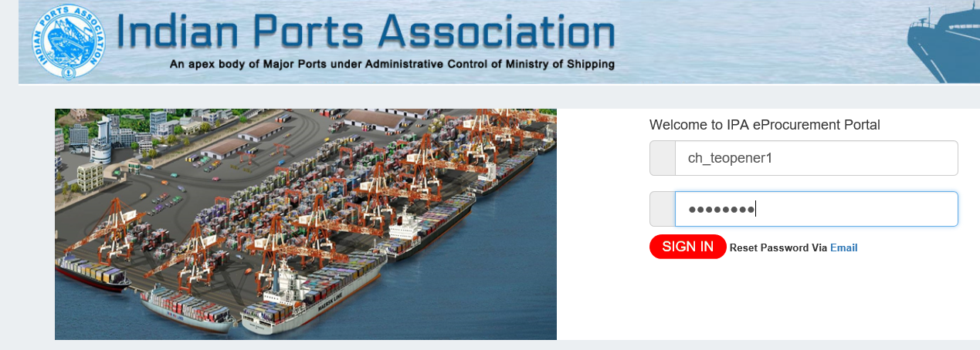

  - Go to “Work Overview” and Select RFx Number Line item
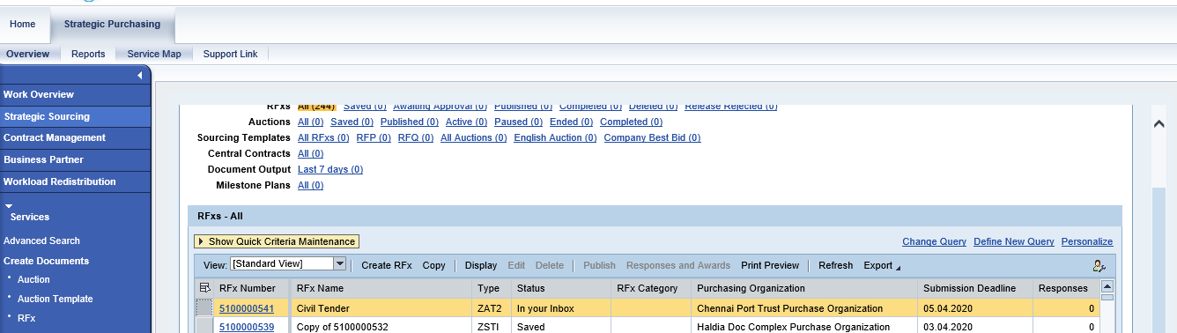

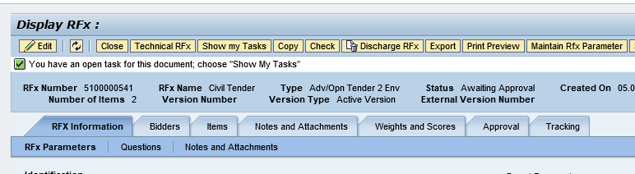
  - Click on “Show my Tasks” and click on Process now
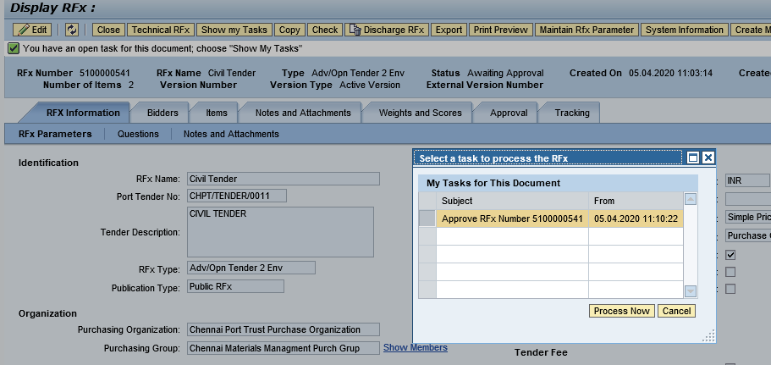

  - Click on “Approve” button

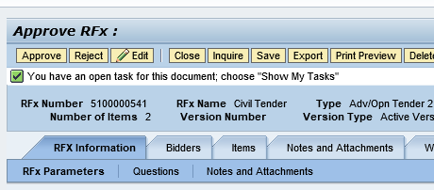
  - RFx is published successfully.
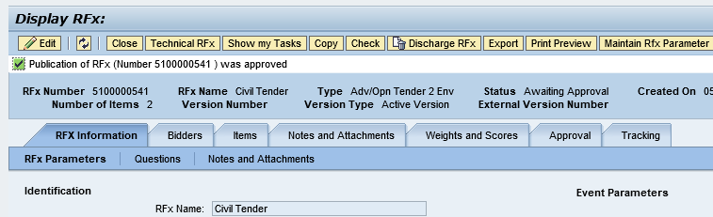

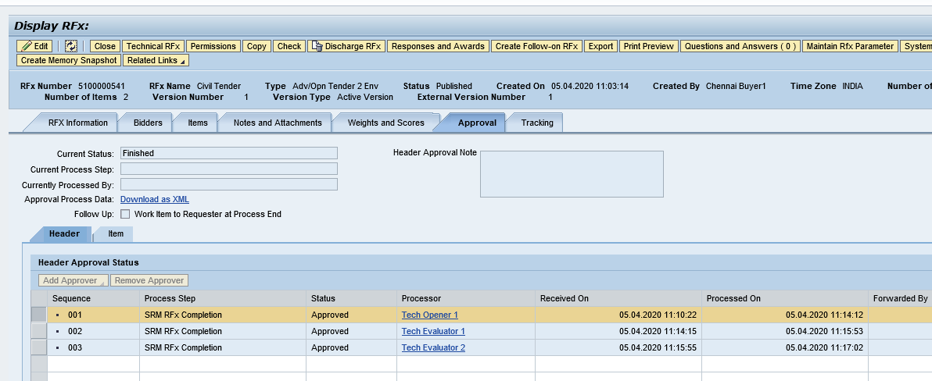

Add Permission
    - Click on “Permission” button and add Tech Opener, Tech Scrutiny, Price Opener, Tech Evaluator, Price Scrutiny and Price Evaluator

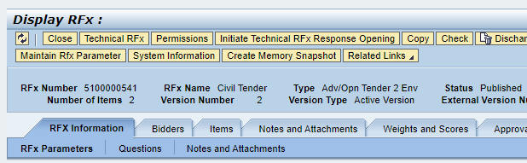
    - All Members are added successfully
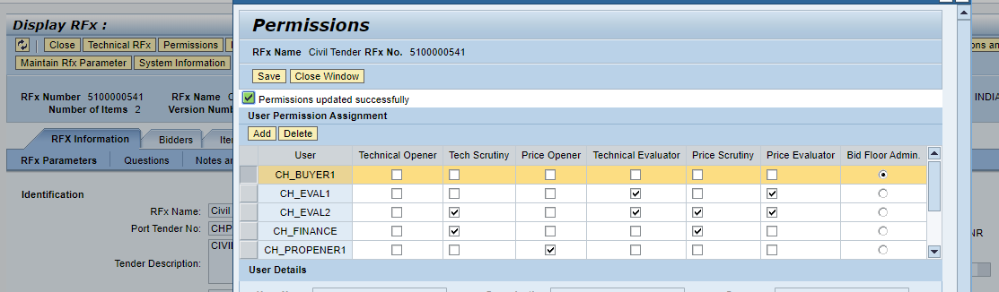

Open Technical RFx
    - Click on “Initiate Technical RFx Response Opening” button and enter Password.
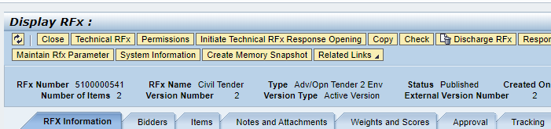

    - Enter Password

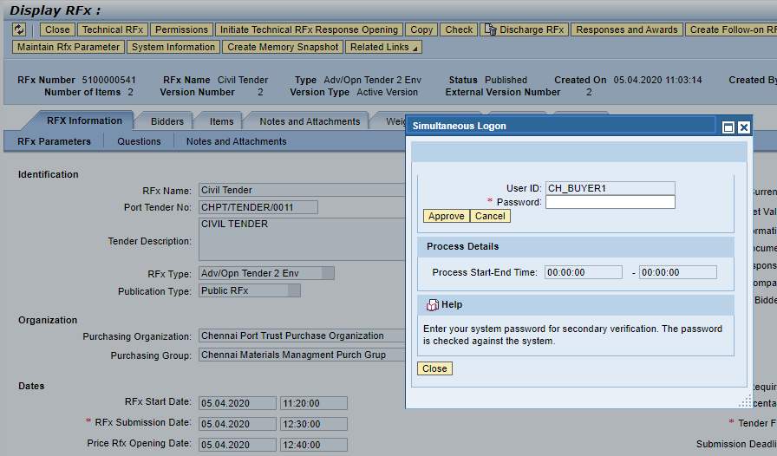

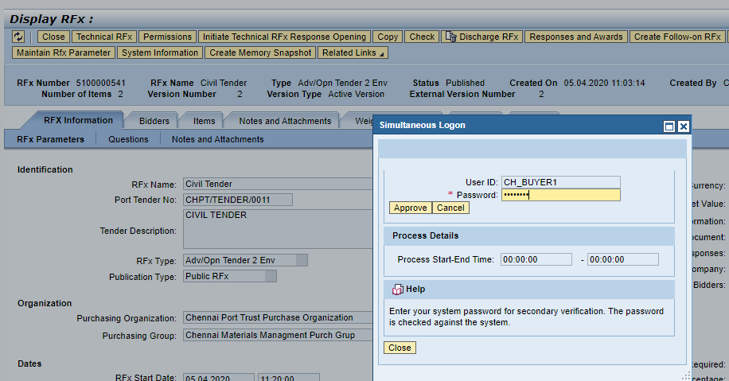

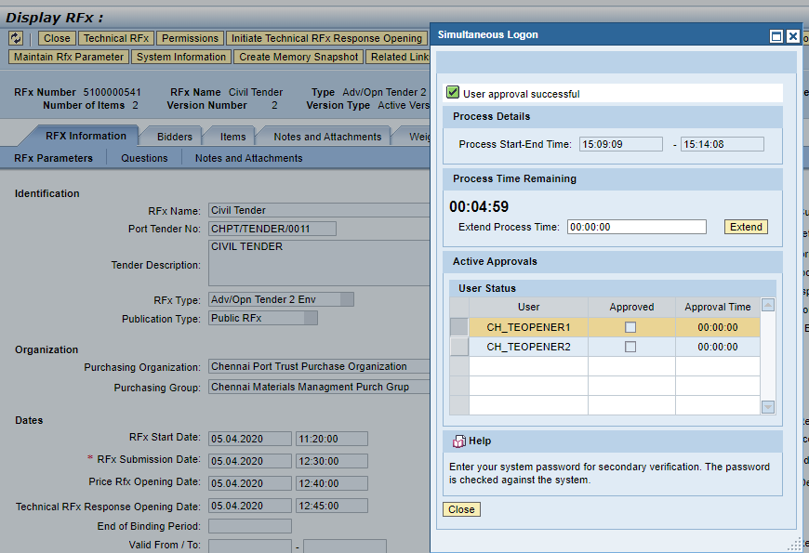
    - Login as Technical Opener
      - Enter User ID and Password
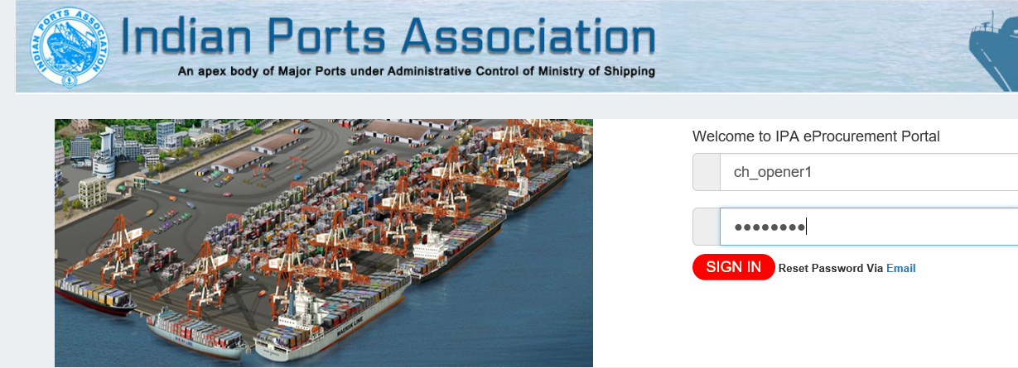

    - Go to RFx number and display RFx
      - Click on “Open Technical RFx Response” button
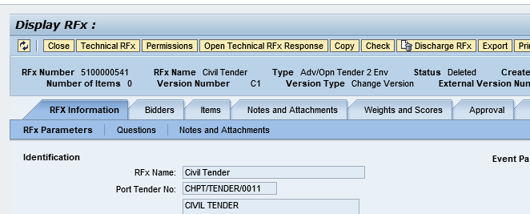
      - Enter Password
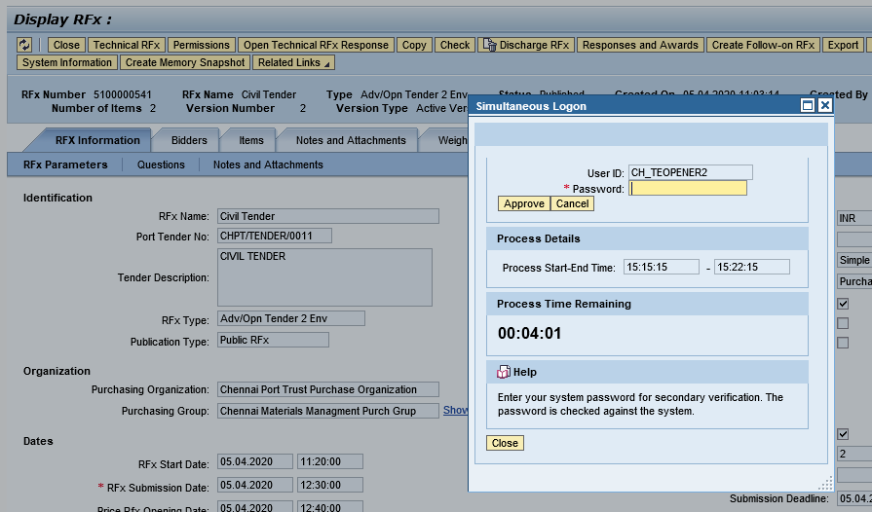

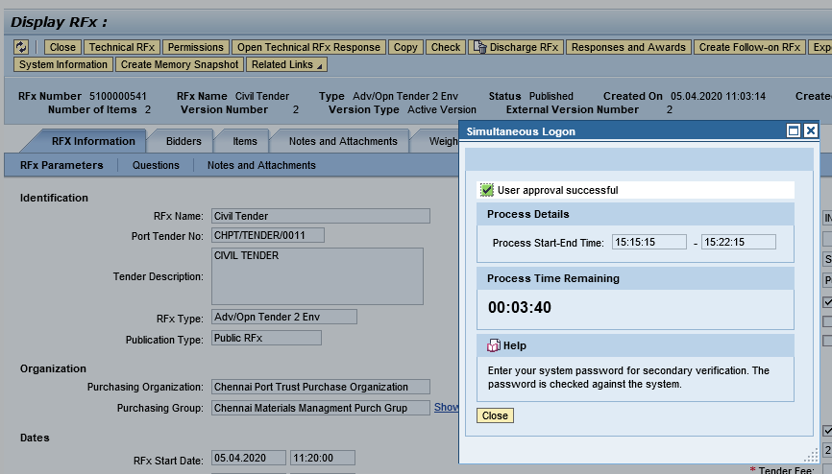

Display Technical Comparative Statement
    - Click on “Response and Award” button
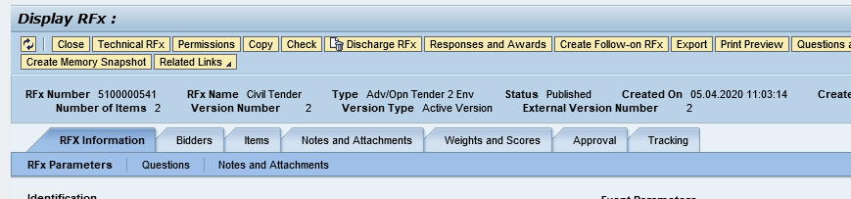
    - Select “Technical Response Activity” Tab and click “TCR Report”
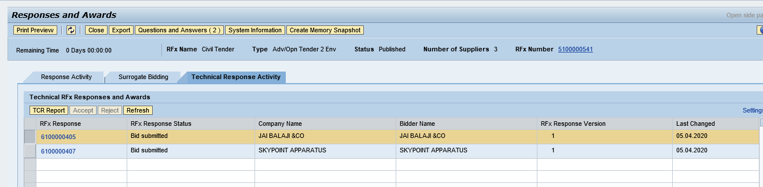
    - Enter Buyer comments for each line item and over all comment.
    - Click on “Forward” button to send TCR Report to Scurrility and Committee Members
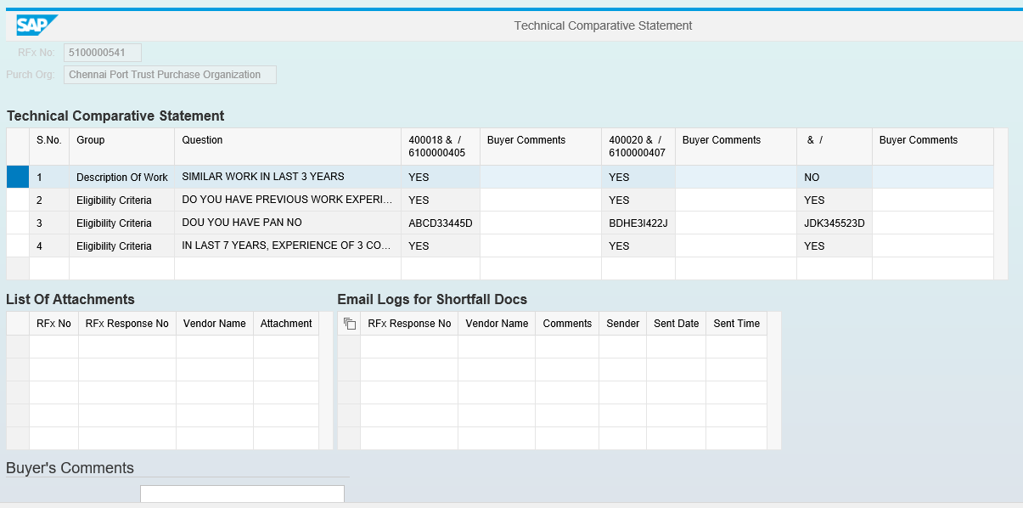

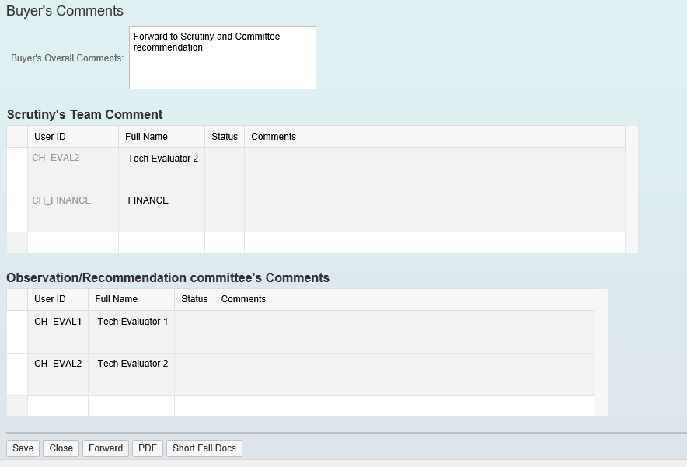

Security & Committee Evaluation

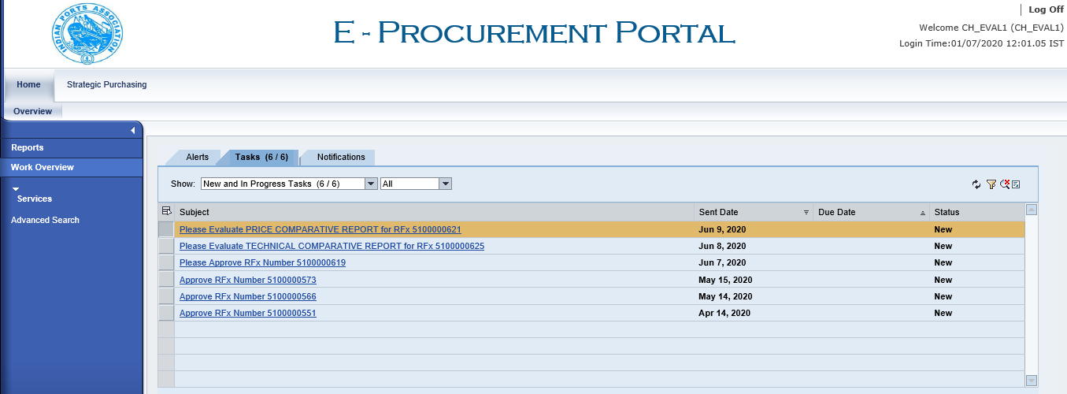

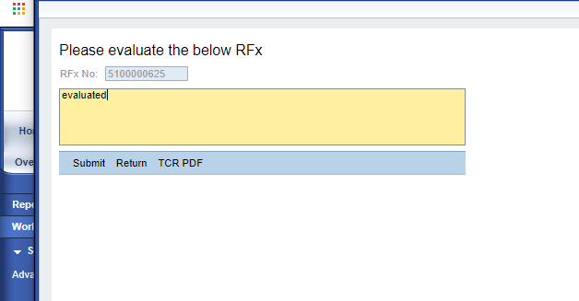

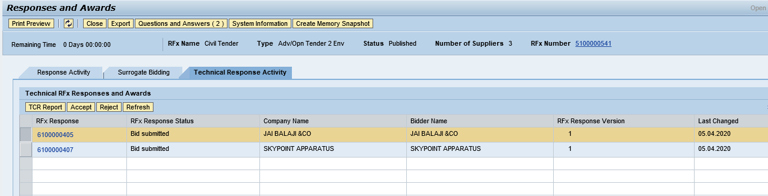

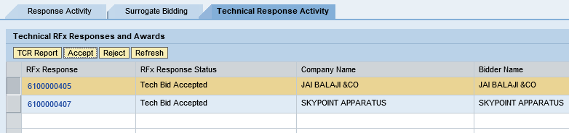

Open Price Response
    - Click on “Initiate Price Response Opening” button

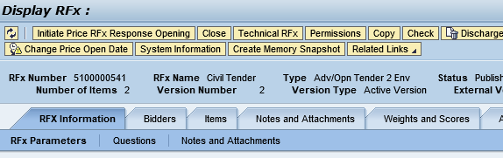
    - Enter Password

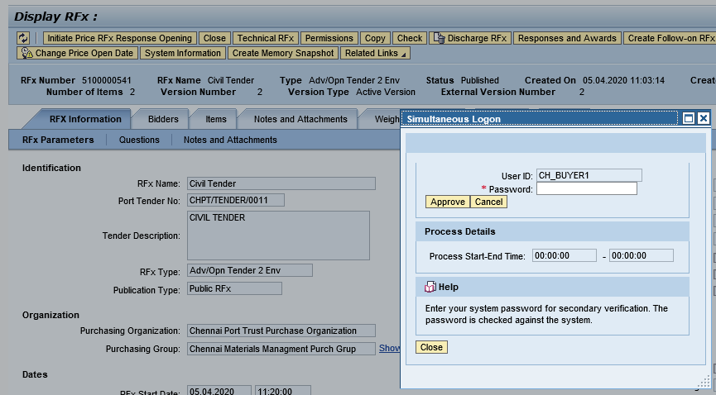

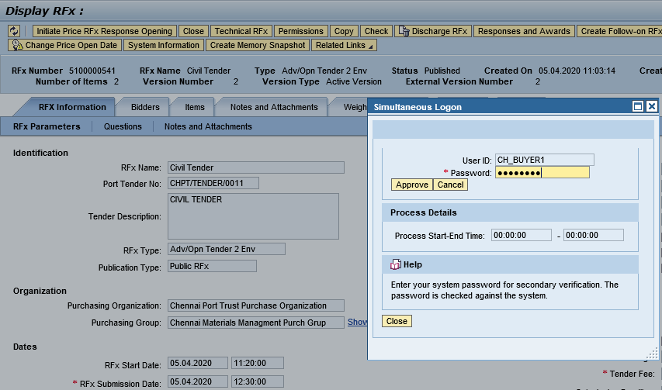
    - Login as Price Opener and “Open Price RFx Response”

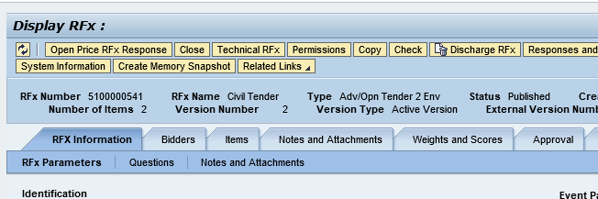
    - Enter Password

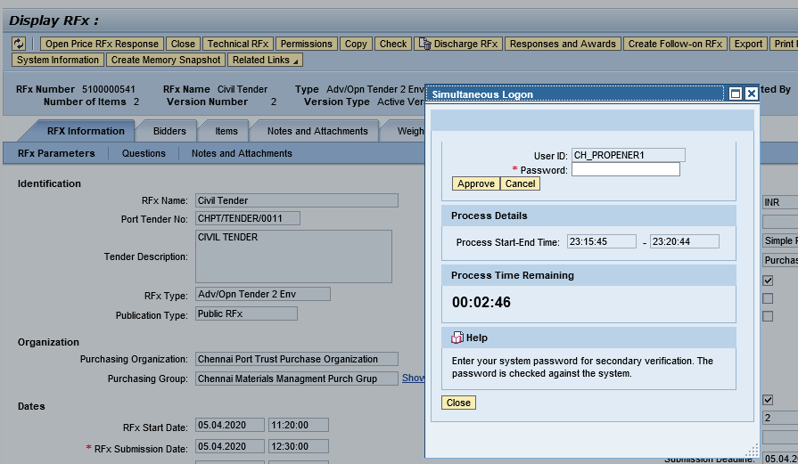

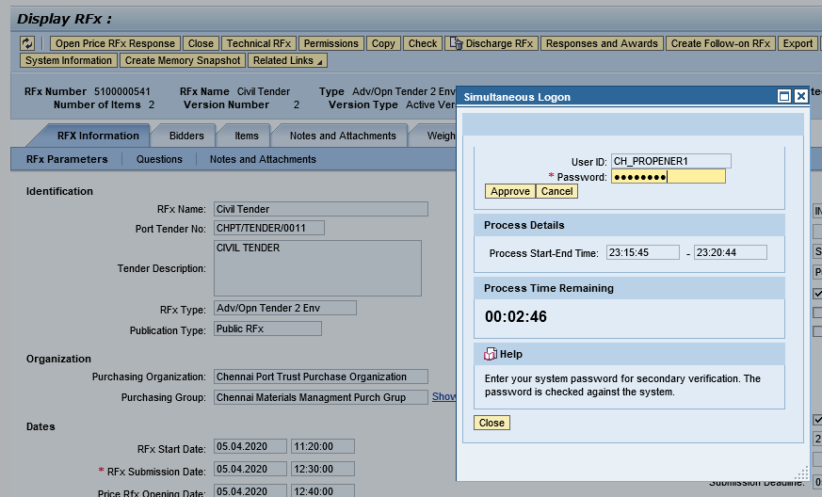

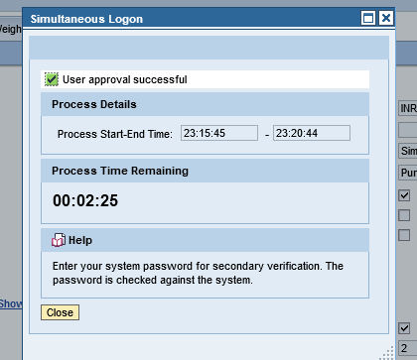
    - Accept/Reject Price Response

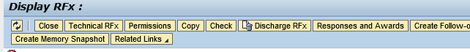
    - Go to “Response and Award”

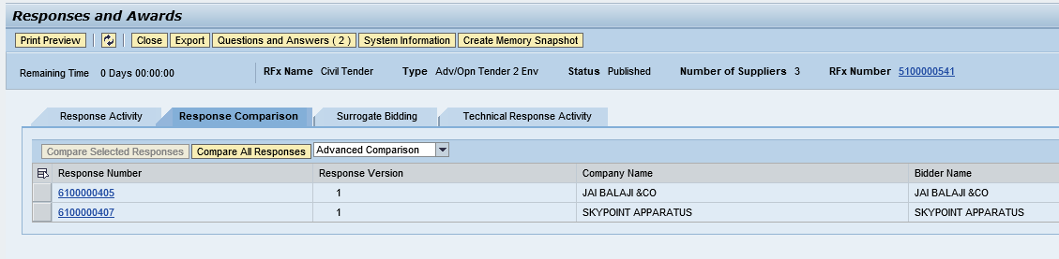

Display PCR Report

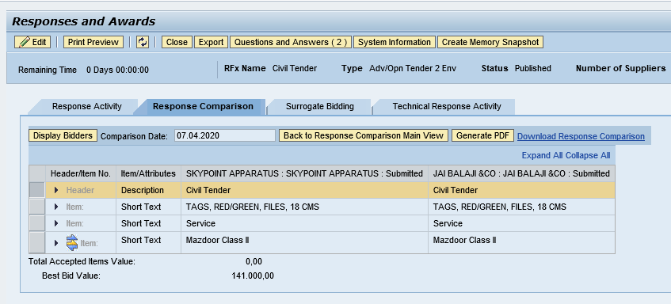

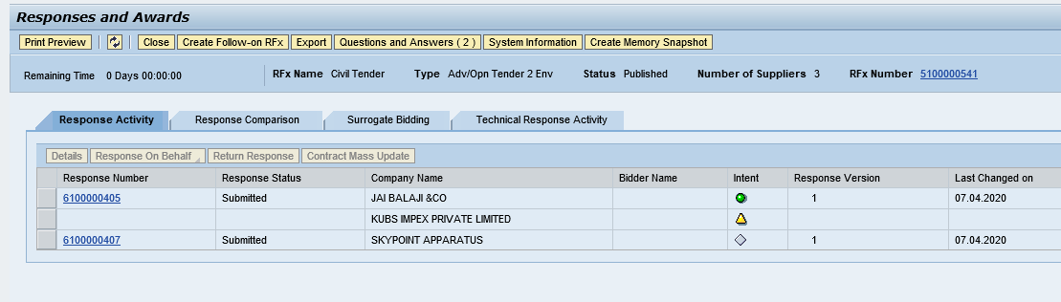

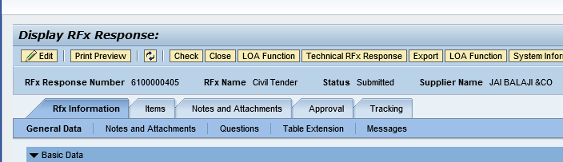
    - Accept/Reject Price Response

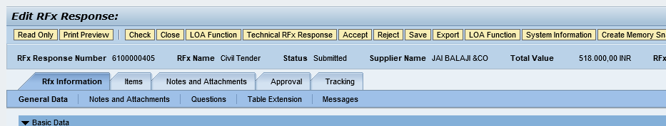

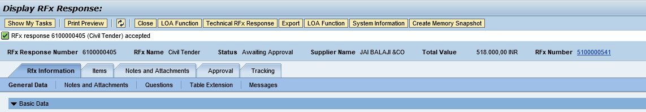

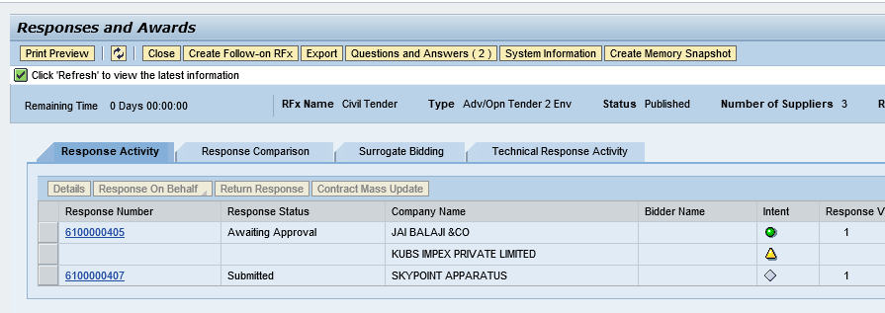

Create Purchase Order

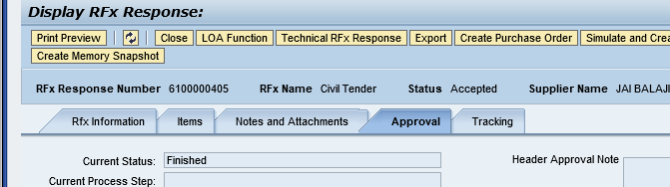

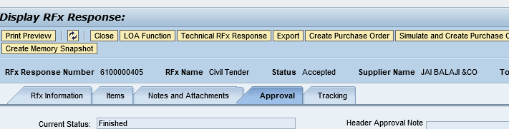
    - Select Transaction Type ZZNB and click “Create Purchase Order”

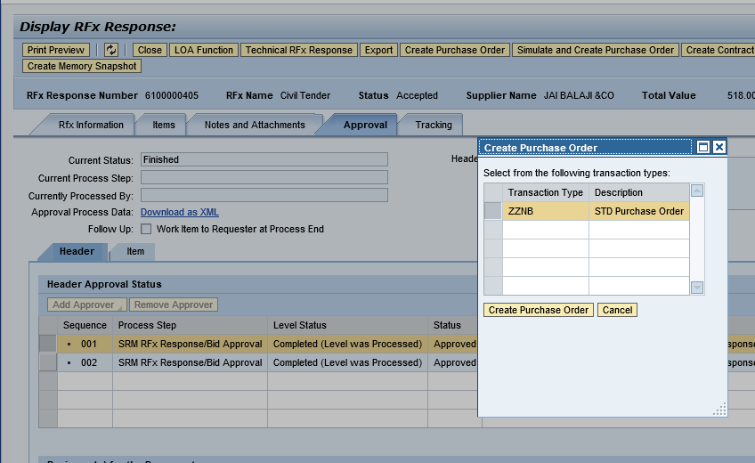
    - Purchase Order created successfully and transfer to HANA system.

