DEENDAYAL PORT AUTHORITY
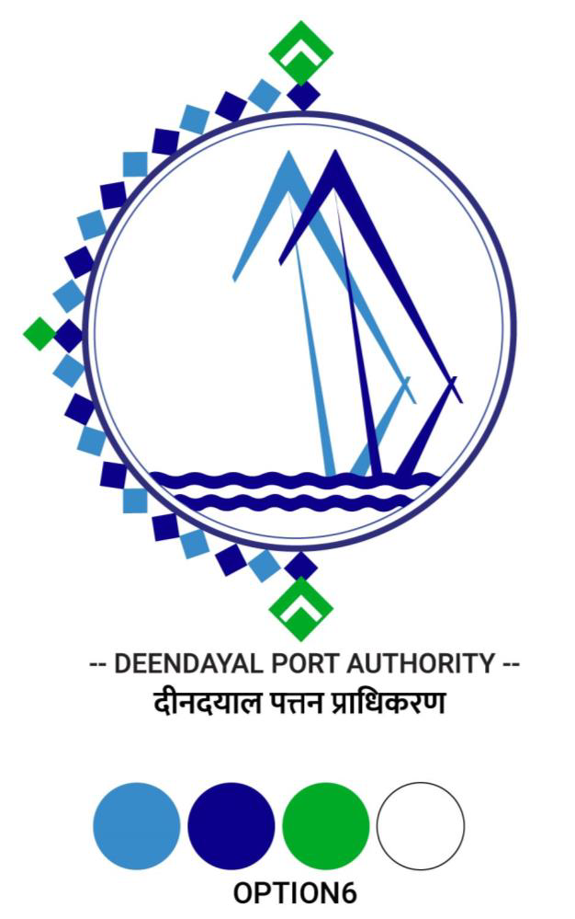

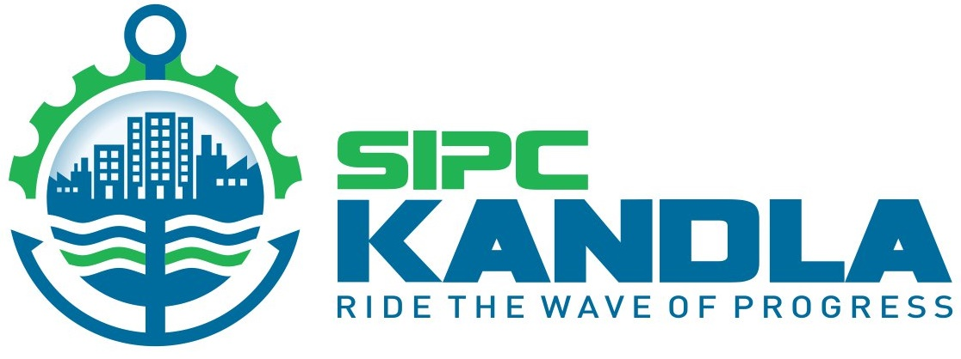

Office of the Executive Engineer,
Harbour Division, Nirman Building, Tel : (02836) 270325
New Kandla (Kutch), Gujarat-370210.
Email ID: - kphdivision@gmail.com

No. : HW/WK/EOI/SBA- Dated : 30.09.2024

To,
M/s. _______

Expression of Interest

Sub. : Swachh Bharat Abhiyan – Providing various Sign Boards, Dustbins inside Cargo Jetty Area and Solid Waste Management.

Sir,
Deendayal Port Authority intends to invite e-tender for the subject work.

Kindly submit your Expression of interest along with budgetary-offer for the subject work on the basis of tentative requirements of material enclosed herewith.

The rates quoted must be inclusive of all taxes, & exclusive of GST.

Your budgetary offer for the above work should reach to the above mentioned address on or before 05.10.2024.

Address :-
Office of the Executive Engineer (H),
Harbour Division, First Floor,
Nirman Building, New Kandla,
Kutchh (Gujarat)
Email : kphdivision@gmail.com

Thanking you,

Encl. : As above

Yours faithfully,

Sd/-
Executive Engineer
Deendayal Port Authority


To,
The Executive Engineer (H)
Deendayal Port Authority
New Kandla

Sub. : Budgetary offer for the work of - "Swachh Bharat Abhiyan - Providing various sign boards, dustbins inside cargo jetty area and solid waste management".

Sr. No. | Short Description of Item | Total Qty. | Rate | Unit | Amount
1 | Supply and erection of Twin Plastic Container bins of 100 liter capacity each separate for wet & dry waste material along with MS stand made of MS square box pipe of 50mm with 4mm thickness including loading unloading transportation and fixing at site by concrete pedestal 500x500x800mm on both legs by excavating/breaking the surface at various locations inside / outside cargo jetty area, complete all the cost of material, labour, as directed by Engineer in charge.
 | At various locations Inside/Outside Cargo Jetty | 200 |  | Nos.

Note : Rates shall be exclusive of GST.

